Dublin Technological University,
Certificate, Cloud Solutions Architecture (2020)

Initial Research and Project Plan

Student Name: Alan Duffin
Student ID: X00159409

Contents

Overview 2
Use Case Outline 3
Initial Research 7
Initial Project Plan 8
Risks 9

Overview

Workflow is a common pattern for solving use cases across a broad range of sectors. These use cases require maintaining state and coordinating operations across sometimes heterogeneous / distributed participants over extended time periods. Examples of common problem areas include loan/insurance origination, order management, billing systems and logistics fulfilment.
These systems have a common problem set that must be solved. The workflow pattern must address requirements such as state transition, error handling, component / service integration and human interaction/decision making.
Many vendors have designed solution frameworks around the concept of the Finite State Machine such as BPEL (Business Process Execution Language). The growth of SaaS and Paas platforms has allowed users to take advantage of fully managed, scalable services for many problem domains including workflow.
My project proposal is to research the available Workflow/Servlerless services that are available from the three largest SaaS Cloud providers: Google Cloud, Amazon Web Services, Microsoft Azure. I will subsequently create a comparison matrix for these SaaS platforms based on a set of required criteria for the Workflow use case that is to be implemented. This matrix will be used to select a Cloud vendor platform upon which to implement the use case. Some of these criteria/features are:
- Features
- Ease of use
- Latency
- Cost
- Maintainability / Trobleshooting
- State Maintenance / Error Handling.

Use Case Outline

Loan origination is the process by which a borrower applies for a new loan, and a lender processes that application. Origination includes all the steps from taking a loan application up to drawdown of funds or refusal of the application.
The loan origination process has many steps, including:
- Loan application — The homebuyer fills out a loan application form.
- Documents — The buyer submits documentation for income, employment and financial status.
- Underwriting — The lender reviews the loan application, verifies the buyer’s credit and determines if the buyer’s income and financial status is such that the buyer qualifies for the loan.
- Finalise loan application — Once the terms are agreed on, the loan application is processed by the lender, going through several departments, such as underwriting and documentation processing.
- Loan approval — After final processing, the lender decides to approve or reject the loan application.

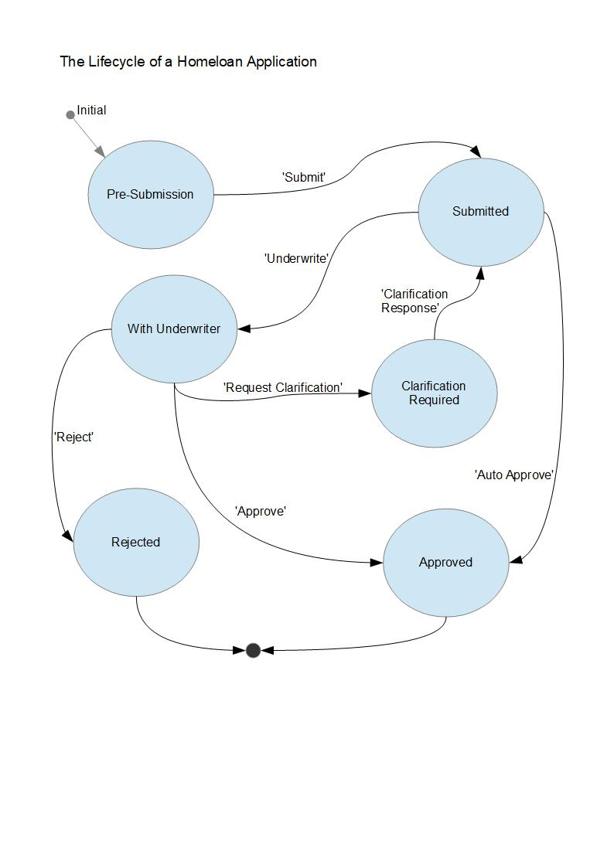
Human Actors
Branch Staff | Actor 1
Broker | Actor 2
Customer | Actor 3
Underwriter | Actor 4

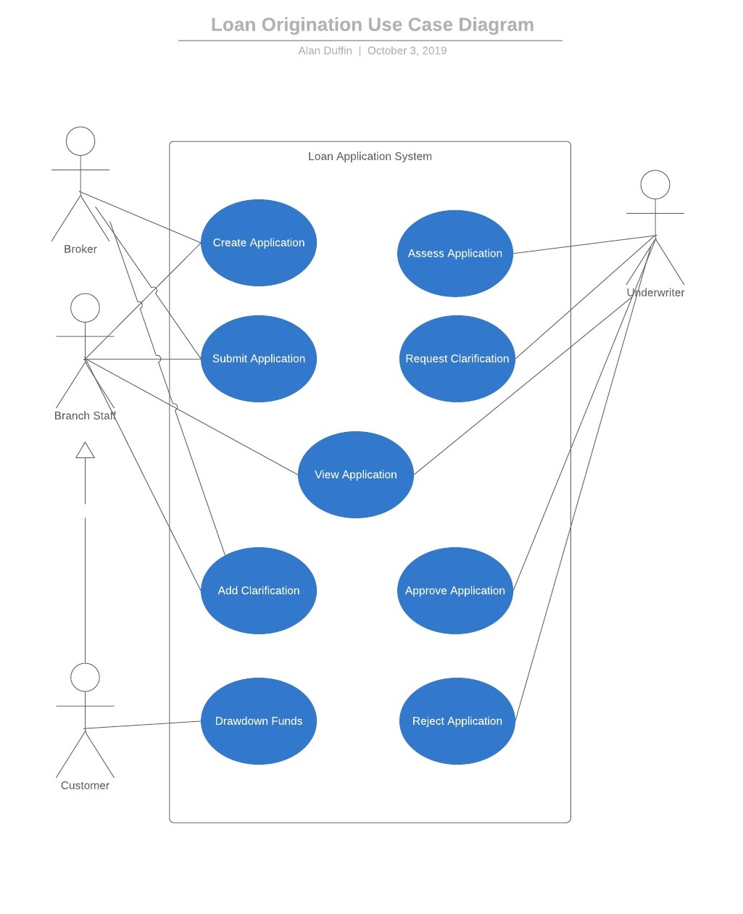

The Bank Branch Staff Member or Broker (Actor 1) via the user interface will view the list of active Loan Applications.
- Actor 1 can choose to view the details of any individual Loan Application.
- Actor 1 can create a new Loan Application on behalf of a customer.
- Actor 1 can input all required customer and loan details.
- After reviewing all information Actor 1 can submit the Loan application into the Approvals workflow. This should initiate a workflow execution.
- Possibly notifications should be sent to all human actors of loan application state changes. This could be via email, or a front end notification.
- The workflow execution should consist of the steps shown in the table below (not exhaustive).

Step Number | Workflow Component
1 | Validate that all mandatory data has been input for the Approval process
2 | Run the affordability calculator and validate that the case does not fall outside loan rules e.g. age of applicants, loan term, unsuitable employment, not in current employment for long enough etc.
3 | Decision rule to either auto approve or route the application to an Underwriter (Actor 2) for human review.
4 | The Auto Approval service will mark the application as approved and notify Actor 1. (Notification method unknown at the moment)
5 | The Underwriters have discretion to approve the loan application based on extenuating circumstances such as Junior doctor with immediate prospects of salary increases and stable job prospects.
6 | If manual Approval is required the workflow will notify Actor 4 that the Loan Application is awaiting review and pause execution.
7 | Actor 4 must open the Loan Application and review details.
8 | Actor 4 can then choose to Approve or Decline the application. This is done via the front end and calls a service that restarts the workflow execution.
9 | The workflow will then notify Actor 1 and the Customer (Actor 3) using some mechanism.
10 | The workflow will terminate.

Initial Research

My initial reseach of the Google, Microsoft and AWS PaaS services, show that the services listed below can be considered as candidate solution platforms for the workflow use-case of this project.
Each of the PaaS cloud vendors provide services that will be required for this use case. These provide solutions for the following problem domains:
1 Workflow Orchestration
2 Servlerless hosting of business logic.
3 Publish/Subcribe for messaging/notification.
4 Queuing for asynchronous task processing.

SaaS Provider | Workflow related Services
Google Cloud | Cloud Composer. https://cloud.google.com/composer/  Apache Airflow. https://airflow.apache.org/  Cloud Functions. https://cloud.google.com/functions/  Cloud Pub/Sub. https://cloud.google.com/pubsub/docs/
Microsoft Azure | Logic Apps. https://azure.microsoft.com/en-us/services/logic-apps/  Microsoft Flow. https://flow.microsoft.com/en-us/  Azure Functions. https://azure.microsoft.com/en-us/services/functions/  Event Grid. https://azure.microsoft.com/en-us/services/event-grid/  Queue Storage. https://azure.microsoft.com/en-us/services/storage/queues/
Amazon Web Services | Step Funtions. https://aws.amazon.com/step-functions/  Lambda. https://aws.amazon.com/lambda/  SNS. https://aws.amazon.com/sns/  SQS. https://aws.amazon.com/sqs/

Initial Project Plan

 | Tasks | Dates
Literature Review | Amazon Web Services | Sun 13th - 20th Oct
 | Microsoft Azure
 | Google Cloud Platform
Technology Assessment | Amazon Web Services | Sun 20th - 27th Oct
 | Microsoft Azure
 | Google Cloud Platform
Implementation Iteration 1 | Create Database Schema.  Implement Database CRUD code.  Implement / Test Individual Services using Serverless functions and REST API. | Sun 27th Oct - 10th Nov
Implementation Iteration 2 | Create initial Workflow orchestration and tasks.  Integration testing with services from Iteration 1. | Sun 10th - 24th Nov
Implementation Iteration 3 | Create / Test User Interface.  Create / Test Nofication mechanisms for Human actors.  Final integration testing | Sun 24th Nov - 8th Dec
Prepare Final Report |  | Sun 8th^{th} - 15th Dec

Risks
- The Moodle Project schedule lists 1 week for Literature Review and 1 week for R & D of all the required services across the 3 cloud vendors. I do not believe this to be achievable.
- To build a fully functional project implementation will require a combination of many services. For example, if implemented on AWS these would include SNS, SQS, Lambda, S3, API Gateway. A browser-based frontend will be required to allow user interaction. This would require significant software development using HTML, javascript, etc perhaps using AWS frameworks such as ASW Amplify, Cognito, IAM. There is a risk that the software development effort may not be achievable in the allotted timeframe.
- Design/Architecture lacks flexibility, is not fit for purpose or is infeasible.
- Estimates are inaccurate perhaps due to scope creep or required activities are missing from scope.
- Learning curves lead to delays because developer is inexperienced.
- Requirements are incomplete or fail to align with available systems/services.User interface doesn't allow users to complete tasks or is low quality.

